Linked List Data Structure (Theory + Code)

🔹 1. What is a Linked List?
A Linked List is a linear data structure where elements are:
- Stored in non-contiguous memory locations
- Connected using pointers (references)
👉 Each element is called a node

🔹 Structure of a Node
Each node contains:
- Data → actual value
- Next Pointer → address of next node
[data | next]

🔹 Why Linked List Exists?
Arrays have limitations:
- Fixed size
- Costly insertion/deletion
👉 Linked List solves this by:
- Allowing dynamic size
- Efficient insertion/deletion

🔵 Linked List vs Array (Conceptual Understanding)
Feature | Linked List | Array
Memory | Non-contiguous | Contiguous
Access | Sequential | Direct (index)
Insert/Delete | Fast | Slow
Size | Dynamic | Fixed
👉 Key idea:
- Arrays = fast access
- Linked List = flexible updates

🟡 2. Types of Linked Lists

🔹 1. Singly Linked List
- Each node points to next node
- Last node → null
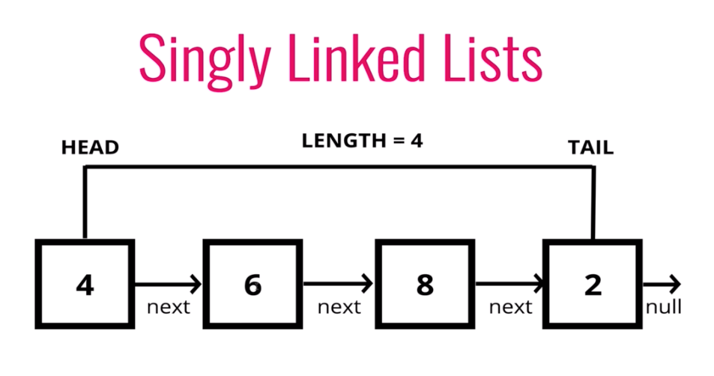

👉 Traversal is one direction only

🔹 2. Doubly Linked List
- Each node has:
  - prev
  - next
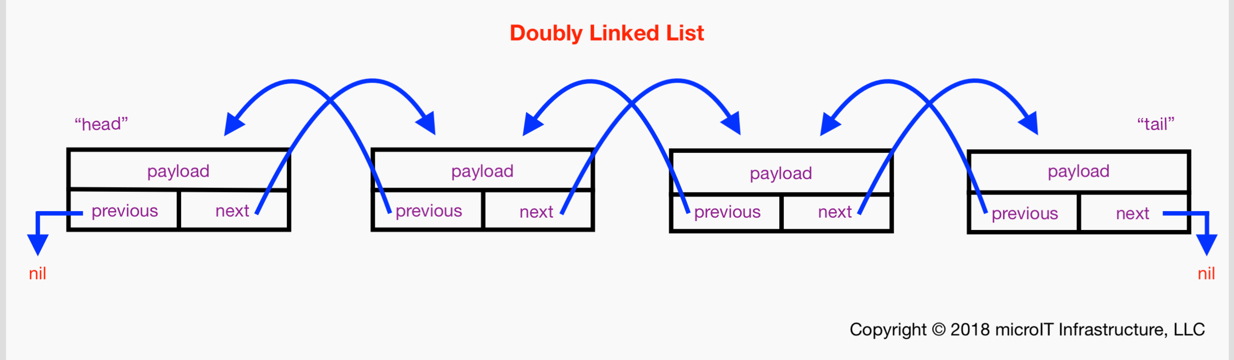
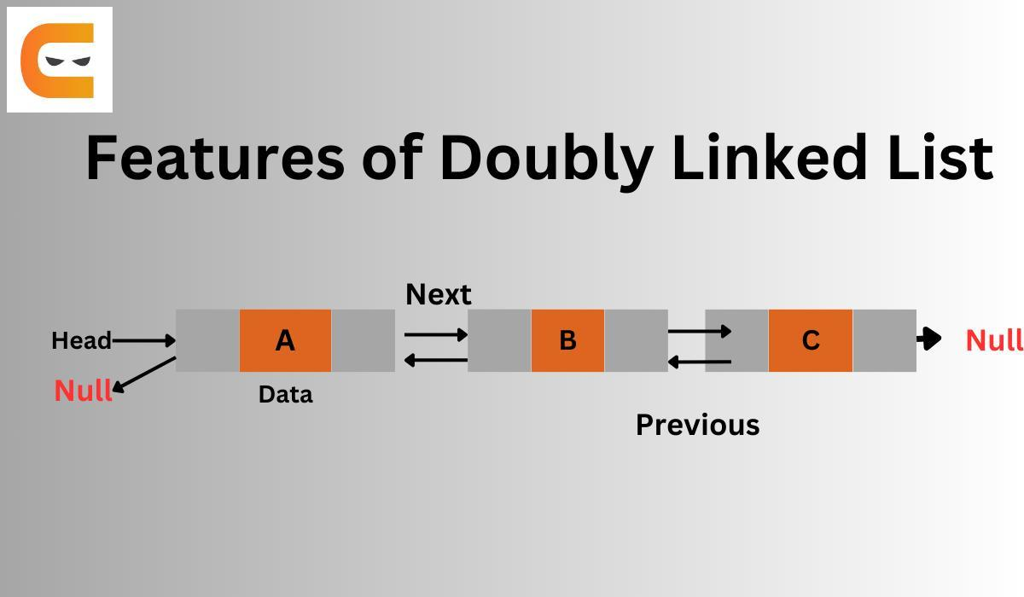
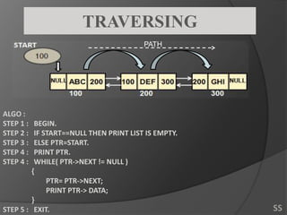
👉 Can move forward and backward

🔹 3. Circular Linked List
- Last node points back to head

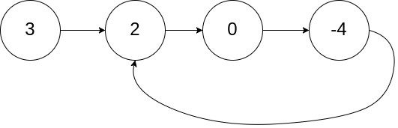
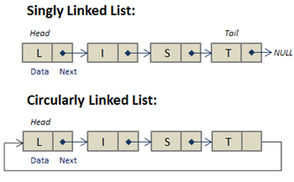
👉 No null, forms a loop

🟣 3. Internal Working (Important Theory)
🔹 Memory Representation
Nodes are stored anywhere in memory:
Head → [10 | 200] → [20 | 500] → [30 | null]
👉 Even though addresses are random, pointers maintain order

🔹 Traversal Concept
Start from head, follow next until null
👉 Time Complexity = O(n)

🔴 4. Java Implementation (Base Structure)
class ListNode {
int data;
ListNode next;
ListNode(int data) {
this.data = data;
this.next = null;
}
}

🟠 5. Operations (Theory + Code)

🔹 1. Traversal
💡 Theory
- Visit each node one by one
- Used in almost all operations
void printList(ListNode head) {
ListNode temp = head;
while (temp != null) {
System.out.print(temp.data + " -> ");
temp = temp.next;
}
}

🔹 2. Length of Linked List
💡 Theory
- Count nodes by traversing
int length(ListNode head) {
int count = 0;
while (head != null) {
count++;
head = head.next;
}
return count;
}

🔹 3. Search
💡 Theory
- Linear search (no indexing)
boolean search(ListNode head, int key) {
while (head != null) {
if (head.data == key) return true;
head = head.next;
}
return false;
}

🟤 6. Insertion (Concept + Code)

🔹 Insert at Beginning
💡 Theory
- New node becomes new head
ListNode insertAtHead(ListNode head, int data) {
ListNode newNode = new ListNode(data);
newNode.next = head;
return newNode;
}
👉 Time: O(1)

🔹 Insert at End
💡 Theory
- Traverse to last node, attach new node
ListNode insertAtEnd(ListNode head, int data) {
ListNode newNode = new ListNode(data);
if (head == null) return newNode;
ListNode temp = head;
while (temp.next != null) {
temp = temp.next;
}
temp.next = newNode;
return head;
}
👉 Time: O(n)

🔹 Insert at Position
💡 Theory
- Reach position, adjust pointers
ListNode insertAtPosition(ListNode head, int pos, int data) {
if (pos == 0) return insertAtHead(head, data);
ListNode temp = head;
for (int i = 0; i < pos - 1; i++) {
temp = temp.next;
}
ListNode newNode = new ListNode(data);
newNode.next = temp.next;
temp.next = newNode;
return head;
}

⚫ 7. Deletion (Concept + Code)

🔹 Delete by Key
💡 Theory
- Find node → skip it
ListNode deleteByKey(ListNode head, int key) {
if (head == null) return null;
if (head.data == key) return head.next;
ListNode temp = head;
while (temp.next != null && temp.next.data != key) {
temp = temp.next;
}
if (temp.next != null) {
temp.next = temp.next.next;
}
return head;
}

🔹 Delete at Position
ListNode deleteAtPosition(ListNode head, int pos) {
if (pos == 0) return head.next;
ListNode temp = head;
for (int i = 0; i < pos - 1; i++) {
temp = temp.next;
}
if (temp.next != null) {
temp.next = temp.next.next;
}
return head;
}

🔵 8. Important Concepts (Interview Level)

🔹 Reverse Linked List
💡 Theory
- Reverse pointer direction
ListNode reverse(ListNode head) {
ListNode prev = null, curr = head;
while (curr != null) {
ListNode next = curr.next;
curr.next = prev;
prev = curr;
curr = next;
}
return prev;
}

🔹 Two Pointer Technique
💡 Used in:
- Finding middle
- Detecting cycle
- Nth from end

🔹 Nth Node from End
int getNthFromEnd(ListNode head, int n) {
ListNode fast = head, slow = head;
for (int i = 0; i < n; i++) {
fast = fast.next;
}
while (fast != null) {
fast = fast.next;
slow = slow.next;
}
return slow.data;
}

🔹 Cycle Detection (Floyd’s Algorithm)
💡 Theory
- Slow moves 1 step
- Fast moves 2 steps
- If cycle exists → they meet
boolean hasCycle(ListNode head) {
ListNode slow = head, fast = head;
while (fast != null && fast.next != null) {
slow = slow.next;
fast = fast.next.next;
if (slow == fast) return true;
}
return false;
}

🟢 9. Applications of Linked List
- Stack implementation
- Queue implementation
- LRU Cache
- Graph adjacency list
- Memory management

🔥 Final Understanding (Very Important)
👉 Linked List is best when:
- Frequent insert/delete needed
👉 Array is best when:
- Fast access required

